**Alexandria University**

**Faculty of Engineering**

**Electronics and Communications Engineering Program**

**2023-2024**

Full Custom Design of

**4-Bit Ripple Carry Adder**

**VLSI - EEC 433**

Spring 2024

By Student:

**AbdulRahman Ahmad Hasan AlSindiony**

**Electronics and Communications Engineering**

**Alexandria University**

Inverter Characteristic Curve

**3**

**3**

**3**

**3**

**3**

**3**

**1**

**1**

**1**

**1**

**2**

**2**

**2**

**2**

**2**

**2**

**2**

**2**

**2**

**2**

**2**

**2**

**2**

**2**

**2**

**2**

**2**

**2**

Full Adder Circuit Schematic

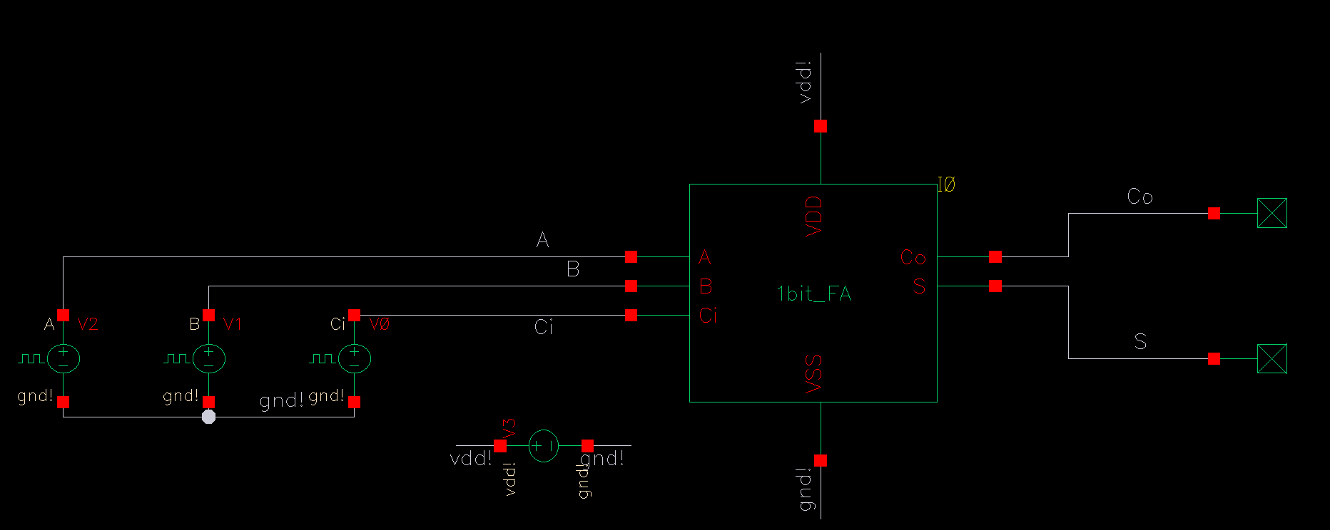

1 bit Full Adder symbol and Test bench

Ci

B

A

S

Co

Verifying the Functionality of the Full Adder Circuit



Propagation delay for single 1-bit full adder without load = 86.64 pS

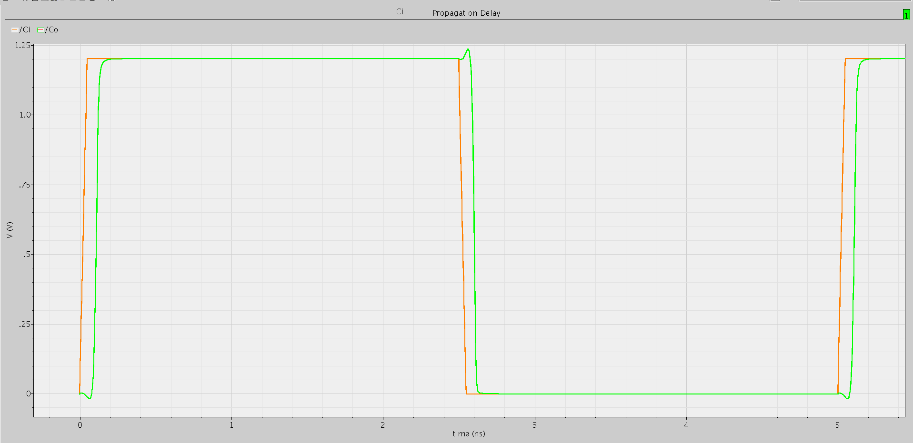

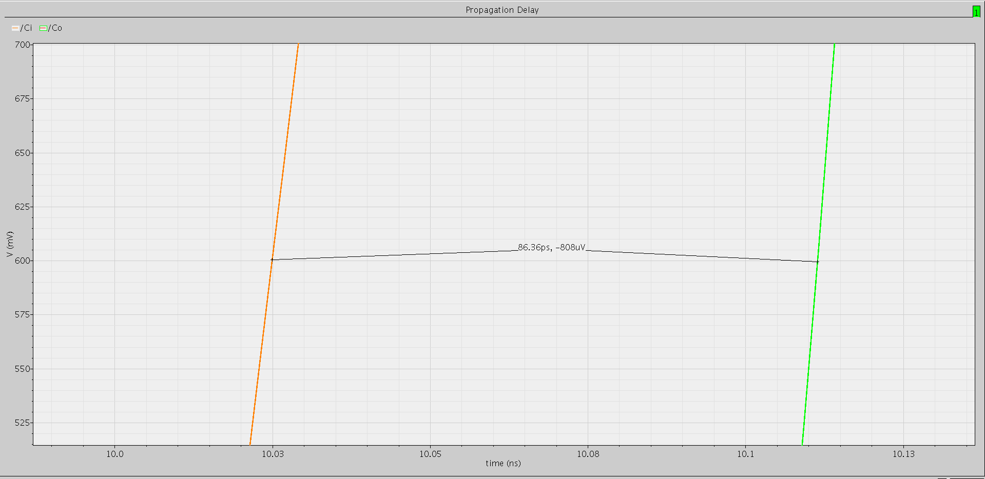



Power Consumption = 15.5 uW

Test bench schematic for calculating the propagation delay with 1 FA Load



Propagation delay for one loaded 1-bit FA = 139.2 pS

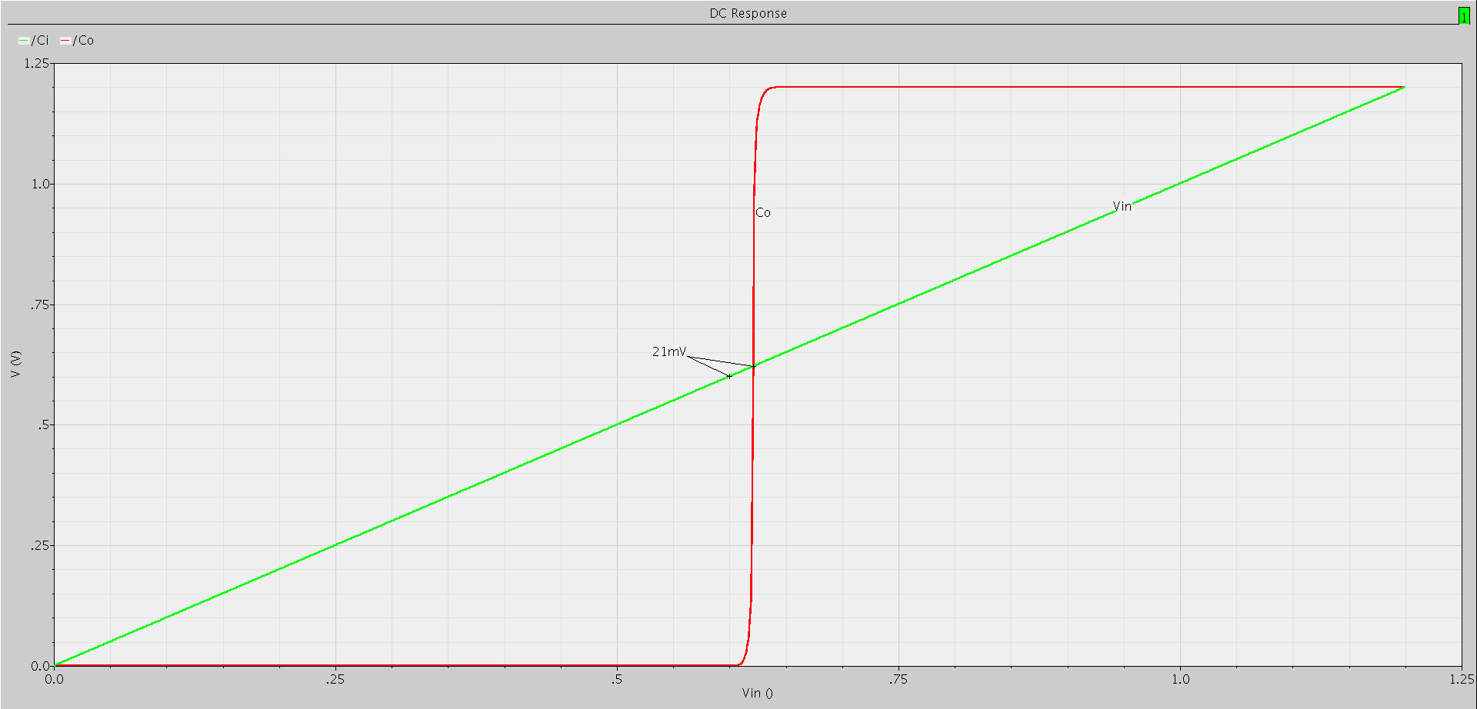

DC Transfer Characteristics, Changing “Cin” from 0 to 1.2 V linearly and monitoring “Co”.

The mid point is 620 mV, we can redesign for closer point to 600 mV.

Circuit Test Bench, with Ideal 4-bit Carry Adder to verify the output of the designed Circuit

Ideal and Practical “Co” signals

Ideal and Practical “S0” signals

Ideal and Practical “S1” signals

Ideal and Practical “S2” signals

Ideal and Practical “S3” signals

Now we have verified the functionality of the 4-bit ripple carry adder designed circuit.

We have set Ci to 500 MHz clock while A = 0101 , B = 1010, so as to mirror the input carry to the output carry.  


Propagation Delay of the 4-bit ripple adder between Ci and Co of the final stage = 662.5 pS

500 MHz output Carry

Approximate Power Consumption at 500 MHz Switching 

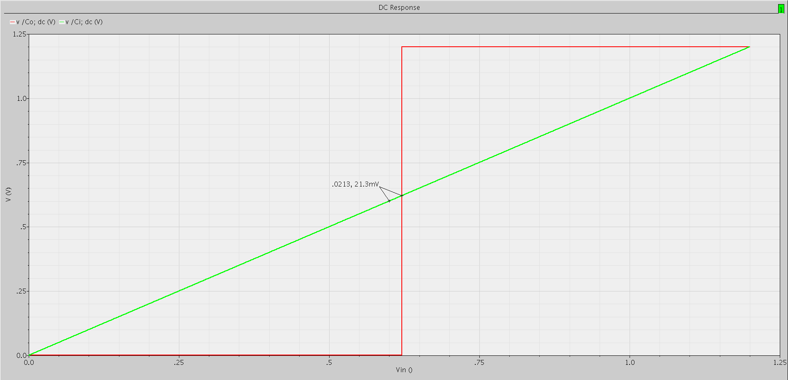

Input/Output Transfer Characteristics for Ci to Co

**CONCLUSION**

**Transistor Sizing for a single bit FA:**

- 2 Inverters each one with PMOS (1105n/130n) and NMOS (250n/130n)

- 3 Stacked PMOS transistors with (3*1105n/130n)

- 3 Stacked NMOS transistors with (3*250n/130n)

- 9 transistors for the rest of PUN (Pull Up Network) with (2*1105n/130n)

- 9 transistors for the rest of PDN (Pull Down Network) with (2*250n/130n)

With total number of 28 Transistors for a single cell.

**Area Estimation:**

PMOS: (9*2 + 3*3 + 2*1) * 1105n * 130n = 4.1658 um2 without routing

NMOS: (9*2 + 3*3 + 2*1) * 250n * 130n = 0.9425 um2 without routing

Approximate area could be = 1.5 * (4.1658 + 0.9425) = 7.6625 um2 for a single 1 bit FA

Total approximate area = 4 * 7.6625 = 30.65 um2

**Propagation Delay: 662.5 pS**

**Power Consumption: 373.2 uW**

**Technology: 130 nm (min Length), 150 nm (min Width)**

Following We will exploit the inverting property where “Inverting all the inputs of a full-adder cell also inverts all the outputs”. This should exclude the extra inverters we added in the odd cells.



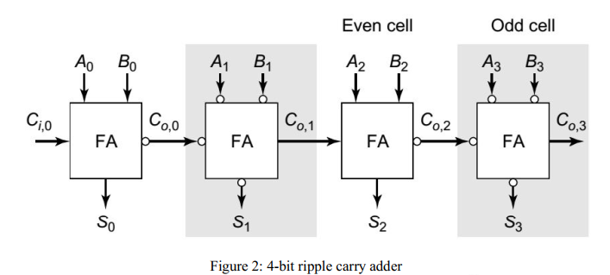



|  |  |
| --- | --- |
| Inverter Symbol | Inverter Schematic |
|  |  |

Wp = 1105n, Wn = 250n

New Schematic for the single FA cell with inverted outputs without extra inverters

The Connections of the inverters, reducing the total inverter count by two and reducing the inverters at the critical path by 4.

The New Design Test Bench

Ideal and Practical “Co” signals

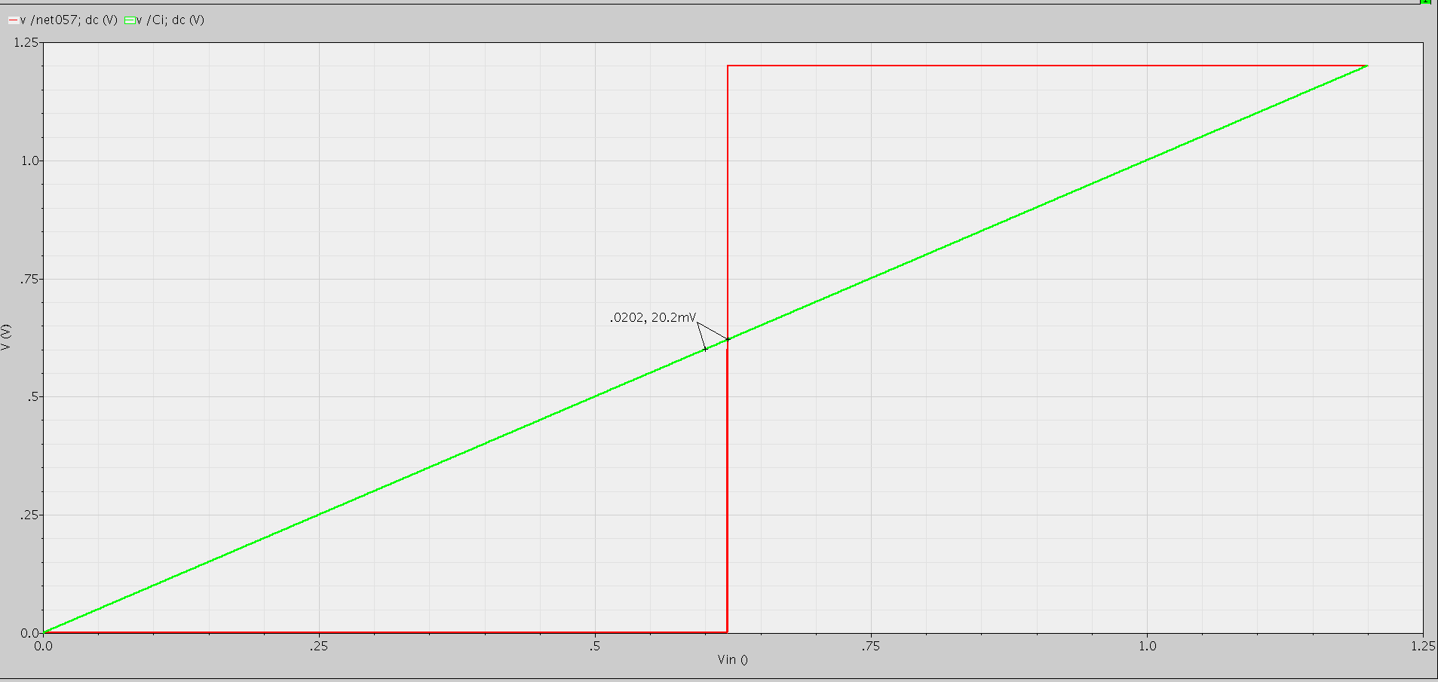

Voltage Transfer Characteristics

Ideal and Practical “S0” signals

Ideal and Practical “S1” signals

Ideal and Practical “S2” signals

Ideal and Practical “S3” signals



Power consumption for the second design = 304.2 uW



The delay Difference between the two designs of 4-bit ripple carry adder = 138.3 pS

The propagation delay of the second design = 526.17 pS

**CONCLUSION**

**Transistor Sizing for a single bit FA:**

- 3 Stacked PMOS transistors with (3*1105n/130n)

- 3 Stacked NMOS transistors with (3*250n/130n)

- 9 transistors for the rest of PUN (Pull Up Network) with (2*1105n/130n)

- 9 transistors for the rest of PDN (Pull Down Network) with (2*250n/130n)

With total number of 24 Transistors for a single cell.

In addition to another 6 Inverters for connections each one with PMOS (1105n/130n) and NMOS (250n/130n)

**Area Estimation:**

PMOS: (9*2 + 3*3 ) * 1105n * 130n = 3.87855 um2 without routing

NMOS: (9*2 + 3*3 ) * 250n * 130n = 0.8775 um2 without routing

Approximate area could be = 1.5 * (3.87855 + 0.8775) = 7.134 um2 for a single 1 bit FA

Total approximate area = 4 * 7.134 + 6*(1.105+0.250)*0.130*1.5= 30.12 um2

**Propagation Delay: 526.17 pS**

**Power Consumption: 304.2 uW**

**Technology: 130 nm (min Length), 150 nm (min Width)**